
Recommended
Performance Schedule
Permitting Council—Executive Director
Uranium In-Situ Recovery (ISR)
March 2026


Table of Contents
Background ii
Recommended Performance Schedule
Uranium In-Situ Recovery (ISR) 1
New Licenses 1
License Renewals 4
Supporting Details 7
References 8


Background
Statutory Requirements: FAST-41 directs the Executive Director of Permitting Council, in consultation with the Permitting Council, to develop RPSs for each category (“sector”) of covered projects. RPSs:
- Include interim and final completion dates for the environmental reviews and authorizations most commonly required for a given category of projects;
- Reflect the most sound and efficient applicable processes, including alignment of federal reviews, reduction of permitting and project delivery time, and consideration of the best practices for public participation;
- Extend no more than two years, to the maximum extent practicable and
consistent with applicable federal law;
- For an RPS that exceeds two years, include an explanation of the factors causing it to be longer than two years; and
- Do not exceed the average time to complete an environmental review or authorization for a project within that category.
In addition, each RPS specifies that any decision by an agency on an environmental review or authorization must be issued not later than 180 days after the date on which all information needed to complete the review or authorization is in the possession of
the agency.
The Executive Director, in consultation with the Permitting Council, reviews and revises the RPSs every two years.
How RPSs are Used: An RPS serves as a starting point from which lead agencies, cooperating and participating agencies, and project sponsors can identify and consider project-specific factors to adjust the RPS to develop transparent and reliable
project timelines.
RPSs are not intended to be all-inclusive, definitive limits. Rather, they are intended to be used as a starting point when agencies are developing project permitting timetables. For example, the RPSs include the most common types of authorizations required for each subsector, but based on considerations unique to a particular project, agencies may need to include or remove other authorizations when developing the permitting timetable for a project. Additionally, a project’s permitting timetable can vary from an RPS based on the project-specific factors below. Thus, the Executive Director recommends that RPSs be used as a starting point for developing project permitting timetables and adjusted based on project-specific factors.
FAST-41 allows permits agencies to vary the permitting timetable for each covered project based on relevant factors, including but not limited to:
- the size and complexity of the covered project;
- the resources available to each participating agency;
- the regional or national economic significance of the project;
- the sensitivity of the natural or historic resources that may be affected by
the project;
- the financing plan for the project; and
- the extent to which similar projects in geographic proximity to the project were recently subject to environmental review or similar procedures under State law.
How RPSs are Developed: The Permitting Council develops, reviews, and revises RPSs. In developing RPSs, the Permitting Council:
- Identifies the common environmental reviews and authorizations for the relevant sectors and subsectors
- Uses Permitting Dashboard data–supplemented with permitting agencies’ policy, guidance, and regulations–to establish baseline durations for relevant reviews
and authorizations
- Accounts for the dependencies between some reviews and authorizations (i.e., instances in which the timing of one review or authorization depends upon another)
- Directly engages with the permitting agencies for review and feedback on the RPSs

Recommended
Performance Schedule
Uranium In-Situ Recovery (ISR)

New Licenses
The uranium ISR RPS for new licenses includes the following environmental reviews
and authorizations:
- Uranium Recovery License (Nuclear Regulatory Commission [NRC])
- Environmental Impact Statement (EIS) (NRC)
- Section 106 Review (NRC)
- Endangered Species Act (ESA) Consultation (Department of the Interior, Fish and Wildlife Service [DOI-FWS])
Figure 1 presents the timing and duration of each environmental review and authorization comprising this RPS.
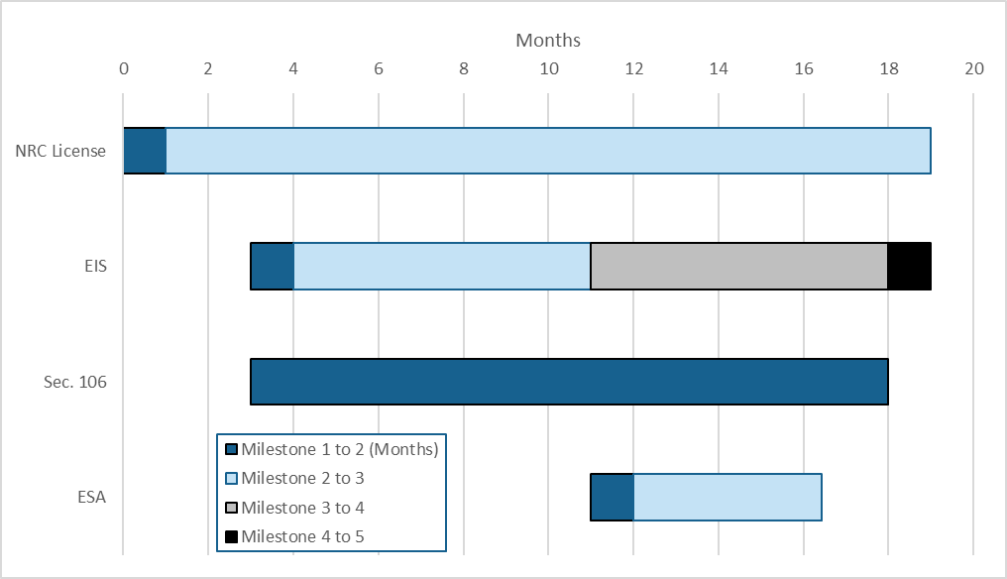
Figure 1: Uranium ISR New License RPS.
Table 1 presents more information about the milestones within each environmental review and authorization comprising this RPS.
Table 1: Details, assumptions, and sources for the Uranium ISR (New Licenses) RPS.
Milestone | Assumptions | Sources/References
Uranium Recovery License
- Initial application submitted | Starts process
- Acceptance  review complete | 1 month after Initial  application submitted | NRC input
- Issuance of  licensing decision | No more than 18 months after Acceptance review complete; concurrent with EIS Record of Decision (ROD) | NRC input, Executive Order 14300, and Dashboard data
EIS
- Issuance of Notice of Intent (NOI) to prepare an EIS | 2 months after Uranium  Recovery License Acceptance review complete | NRC input and Dashboard data
- Scoping | No statutory requirement; use 1 month after EIS NOI for RPS
- Draft EIS | No statutory requirement; use 8 months after EIS NOI for RPS | Dashboard data
- Final EIS | Use 7 months after Draft EIS for RPS | Dashboard data
- Issuance of Lead  Agency ROD | Concurrent with Uranium  Recovery License Issuance of licensing decision | Dashboard data
Section 106 Review
- Consultation initiated with State or Tribal Historic Preservation Officer (SHPO/THPO) | Concurrent with EIS NOI | Advisory Council on Historic Preservation (ACHP) National Environmental Policy Act (NEPA) Section 106 Handbook  and flowchart
- Section 106  consultation concluded | Concurrent with Final EIS | ACHP NEPA Section 106 Handbook and flowchart
ESA Consultation (DOI-FWS)
- ESA Consultation Request Package Submitted | Concurrent with the Draft EIS | DOI input
- FWS determines ESA Consultation Package is Complete – Formal | 30 days after ESA Consultation Request Package Submitted | Endangered Species Consultation Handbook (March 1998) and DOI input
- ESA Consultation Concludes | 135 days after FWS determines  ESA Consultation Package is Complete – Formal | ESA regulation, Endangered Species Consultation Handbook (March 1998), and DOI input

Table 2 is a tool for agencies to compare their project’s permitting timetable to the RPS during the coordinated project plan development process.
Table 2: Uranium ISR (New Licenses) RPS Variance Template.
Review or Authorization and Milestones | RPS |  |  | Project Schedule
Review or Authorization and Milestones | Begin (mo.) | End (mo.) | Duration (mo.) | Duration (mo.) | Explanation of Variance from RPS
Uranium Recovery License | 0 | 19 | 19
(1) Initial application submitted → (2) Acceptance review complete | 0 | 1 | 1
(2) Acceptance review complete → (3) Issuance of licensing decision | 1 | 19 | 18
EIS | 3 | 19 | 16
(1) Issuance of NOI to prepare an EIS → (2) Scoping | 3 | 4 | 1
(2) Scoping → (3) Draft EIS | 4 | 11 | 7
(3) Draft EIS → (4) Final EIS | 11 | 18 | 7
(4) Final EIS → (5) Issuance of Lead Agency ROD | 18 | 19 | 1
Section 106 Review | 3 | 18 | 15
(1) Consultation initiated with SHPO/THPO →  (2) Section 106 consultation concluded | 3 | 18 | 15
ESA Consultation (DOI-FWS) | 11 | 16.4 | 5.4
(1) ESA Consultation Request Package Submitted →  (2) FWS determines ESA Consultation Package is Complete – Formal | 11 | 12 | 1
(2) FWS determines ESA Consultation Package is Complete – Formal →  (3) ESA Consultation Concludes | 12 | 16.4 | 4.4

License Renewals
The uranium ISR RPS for license renewals includes the following environmental reviews and authorizations:
- Uranium Recovery License (NRC)
- Environmental Assessment (EA) (NRC)
- Section 106 Review (NRC)
- Endangered Species Act (ESA) Consultation (DOI-FWS)
Figure 2 presents the timing and duration of each environmental review and authorization comprising this RPS.
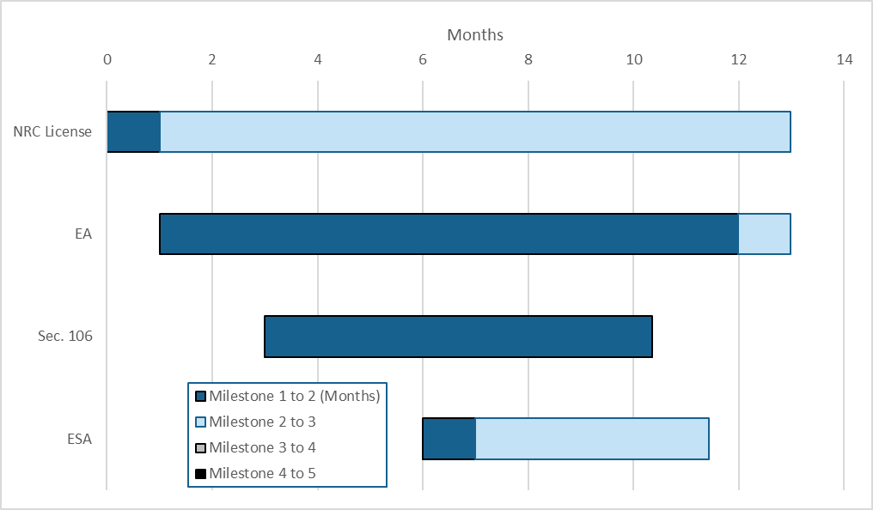
Figure 2: Uranium ISR License Renewal RPS.

Table 3 presents more information about the milestones within each environmental review and authorization comprising this RPS.
Table 3: Details, assumptions, and sources for the Uranium ISR (License Renewals) subsector RPS.
Milestone | Assumptions | Sources/ References
Uranium Recovery License
- Initial application submitted | Starts process
- Acceptance  review complete | 1 month after Initial  application submitted | NRC input
- Issuance of  licensing decision | No more than 12 months after Acceptance review complete; concurrent with EA  Process Concluded | NRC input, Executive Order 14300, and Dashboard data
EA
- Determination to prepare  an EA | Concurrent with Uranium  Recovery License Acceptance review complete | NRC input and Dashboard data
- Issuance of a Final EA | Use 11 months after determination to prepare an EA for RPS; align with Uranium Recovery License
- EA Process Concluded | 1 month after Issuance of a Final EA and concurrent with Uranium Recovery License Issuance of licensing decision | NRC input and Dashboard data
Section 106 Review
- Consultation initiated with SHPO/THPO | 2 months after Determination to prepare an EA | Dashboard data
- Section 106  consultation concluded | 50 days before Issuance of a  Final EA | Dashboard data
ESA Consultation (DOI-FWS)
- ESA Consultation Request Package Submitted | 5 months after Determination to prepare an EA | Dashboard data
- FWS determines ESA Consultation Package is Complete – Formal | 30 days after ESA Consultation Request Package Submitted | Endangered Species Consultation Handbook (March 1998) and  DOI input
- ESA Consultation Concludes | 135 days after FWS determines  ESA Consultation Package is Complete – Formal | ESA regulation, Endangered Species Consultation Handbook (March 1998), and DOI input

Table 4 is a tool for agencies to compare their project’s permitting timetable to the RPS during the coordinated project plan development process.
Table 4: Uranium ISR (License Renewals) RPS Variance Template.
Review or Authorization and Milestones | RPS |  |  | Project Schedule
Review or Authorization and Milestones | Begin (mo.) | End (mo.) | Duration (mo.) | Duration (mo.) | Explanation of Variance from RPS
Uranium Recovery License | 0 | 13 | 13
(1) Initial application submitted → (2) Acceptance review complete | 0 | 1 | 1
(2) Acceptance review complete → (3) Issuance of licensing decision | 1 | 13 | 12
Environmental Assessment (EA) | 1 | 13 | 12
(1) Determination to prepare an EA → (2) Issuance of a Final EA | 1 | 12 | 11
(2) Issuance of a Final EA → (3) EA Process Concluded | 12 | 13 | 1
Section 106 Review | 3 | 10.4 | 7.4
(1) Consultation initiated with SHPO/THPO →  (2) Section 106 consultation concluded | 3 | 10.4 | 7.4
ESA Consultation (DOI-FWS) | 6 | 11.4 | 5.4
(1) ESA Consultation Request Package Submitted →  (2) FWS determines ESA Consultation Package is Complete – Formal | 6 | 7 | 1
(2) FWS determines ESA Consultation Package is Complete – Formal → (3) ESA Consultation Concludes | 7 | 11.4 | 4.4

Supporting Details
The content of these RPSs is specific to the uranium ISR new license and license renewal subsectors of the Mining sector. The RPSs represent a basic, ideal schedule for agencies to use as a tool to develop project-specific schedules based on the appropriate project details of each specific project.
Development of these RPSs was primarily guided by inputs from the Nuclear Regulatory Commission (Facilitating Agency for this subsector and Lead Agency for current FAST-41 projects in this subsector) and is consistent with the requirements under 10 CFR Part 40 and requirements and timelines under the 2019 Nuclear Energy Innovation and Modernization Act (NEIMA), Executive Order 13400, “Ordering the Reform of the Nuclear Regulatory Commission,” and other relevant NRC regulations, guidance, policies,
and processes.
Other dependent agency actions were added to the RPSs as appropriate and figure into the total amount of time for the RPSs. Existing projects on the Permitting Dashboard
were sampled to obtain information on timing, dependencies, and durations for
specific milestones.
The actions and agencies included in these RPSs represent the most common Federal authorizations expected for this subsector based on covered and transparency projects on the Permitting Dashboard. They are not necessarily all-inclusive and the lead agency is responsible for including all Federal reviews and authorizations necessary for bringing the project to construction. While Safe Drinking Water Act (SDWA) Underground Injection Control (UIC) permits and SDWA aquifer exemptions are commonly required authorizations for ISR projects, ISR projects are typically in states where the Environmental Protection Agency (EPA) has delegated implementation authority through primacy for these actions to state regulatory agencies. Since these authorizations are typically not federal, they are not reflected in the RPSs. For Uranium ISR projects on federal or Tribal lands, or in areas with federal mineral rights, additional authorizations may be required.

References
- Executive Order 14300, “Ordering the Reform of the Nuclear Regulatory Commission” https://www.federalregister.gov/documents/2025/05/29/2025-09798/ordering-the-reform-of-the-nuclear-regulatory-commission
- NEIMA Milestone Schedules of Requested Activities of the Commission: https://www.nrc.gov/about-nrc/generic-schedules.html
- NEPA-NHPA Section 106 Handbook: https://www.achp.gov/digital-library-section-106-landing/nepa-and-nhpa-handbook-integrating-nepa-and-section-106
- ACHP Section 106 and Environmental Impact Statement flow chart: https://www.achp.gov/sites/default/files/2022-07/NEPA_Section106_072922.pdf
- Endangered Species Consultation Handbook: https://www.fws.gov/sites/default/files/documents/endangered-species-consultation-handbook.pdf

Ordinary license renewals do not typically meet the $200 million investment threshold (42 U.S.C. §4370m(6)(A)(i)(II)) and therefore are rarely eligible for FAST-41 coverage under the standard “covered project” pathway established at 42 U.S.C. §4370m(6)(A)(i).

