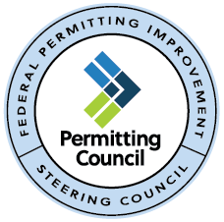
Recommended
Performance Schedule
Executive Director of the Permitting Council
Electricity Transmission
October 2026


Table of Contents
Background ii
Recommended Performance Schedule
Electricity Transmission 1
Supporting Details 5
References 6


Background
Statutory Requirements: FAST-41 directs the Executive Director of the Federal Permitting Improvement Steering Council, in consultation with the Permitting Council, to develop recommended performance schedules (RPSs) for each category (sector) of covered projects. RPSs:
- Include interim and final completion dates for the environmental reviews and authorizations most commonly required for a given category of projects;
- Reflect the most sound and efficient applicable processes, including alignment of federal reviews, reduction of permitting and project delivery time, and consideration of the best practices for public participation;
- Extend no more than two years, to the maximum extent practicable and consistent with applicable federal law;
- For an RPS that exceeds two years, include an explanation of the factors causing it to be longer than two years; and
- Do not exceed the average time to complete an environmental review or authorization for a project within that category.
In addition, each RPS specifies that any decision by an agency on an environmental review or authorization must be issued not later than 180 days after the date on which all information needed to complete the review or authorization is in the possession of the agency.
The Executive Director, in consultation with the Permitting Council, reviews and revises the RPSs every two years.
How RPSs are Used: An RPS serves as a starting point from which lead agencies, cooperating and participating agencies, and project sponsors can identify and consider project-specific factors to adjust the RPS to develop transparent and reliable project timelines.
RPSs are not intended to be all-inclusive, definitive limits. Rather, they are intended to be used as a starting point when agencies are developing project permitting timetables. For example, the RPSs include the most common types of authorizations required for each subsector, but based on considerations unique to a particular project, agencies may need to include or remove other authorizations when developing the permitting timetable for a project. Additionally, a project’s permitting timetable can vary from an RPS based on the project-specific factors below. Thus, the Executive Director recommends that RPSs be used as a starting point for developing project permitting timetables and adjusted based on project-specific factors.
FAST-41 allows agencies to vary the permitting timetable for each covered project based on relevant factors, including but not limited to:
- the size and complexity of the covered project;
- the resources available to each participating agency;
- the regional or national economic significance of the project;
- the sensitivity of the natural or historic resources that may be affected by the project;
- the financing plan for the project; and
- the extent to which similar projects in geographic proximity to the project were recently subject to environmental review or similar procedures under State law.
How RPSs are Developed: The Permitting Council develops, reviews, and revises RPSs. In developing RPSs, the Permitting Council:
- Identifies the common environmental reviews and authorizations for the relevant sectors and subsectors;
- Uses Permitting Dashboard data–supplemented with permitting agencies’ policy, guidance, and regulations–to establish baseline durations for relevant reviews and authorizations;
- Accounts for the dependencies between some reviews and authorizations (i.e., instances in which the timing of one review or authorization depends upon another); and
- Directly engages with the permitting agencies for review and feedback on the RPSs.

Recommended Performance Schedule
Electricity Transmission
The electricity transmission RPS includes the following environmental reviews and authorizations:
- Right-of-Way (ROW) Authorization / Special Use Permit (SUP) (Department of the Interior, Bureau of Land Management [DOI-BLM] or other relevant agency managing land where the project is sited)
- Environmental Impact Statement (EIS) (Facilitating/Lead Agency)
- Section 106 Review (Facilitating/Lead Agency)
- Section 408 Permit (U.S. Army Corps of Engineers [USACE])
- Section 10 of the Rivers and Harbors Act (RHA) of 1899 and Section 404 of the Clean Water Act (CWA) (USACE)
- Endangered Species Act (ESA) Consultation (DOI, Fish and Wildlife Service [DOI-FWS])
Figure 1 presents the timing and duration of each environmental review and authorization comprising this RPS.
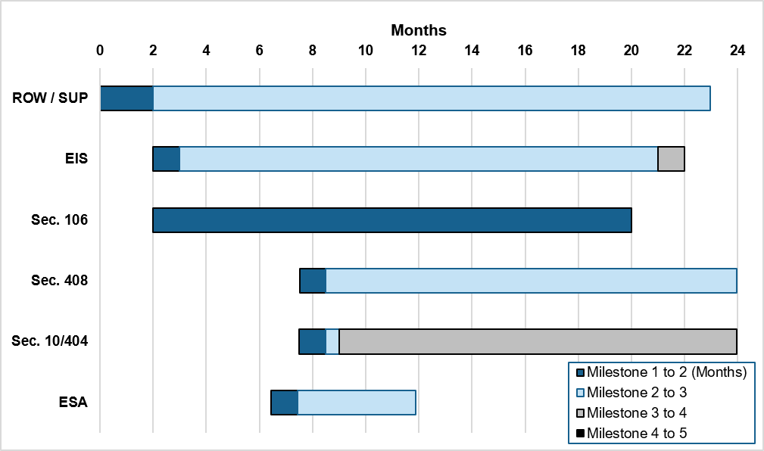
Figure 1: Electricity Transmission RPS.
Table 1 presents more information about the milestones within each environmental review and authorization comprising this RPS.
Table 1: Details, assumptions, and sources for the Electricity Transmission RPS.
Milestone | Assumptions | Sources/References
ROW Authorization / SUP
- Initial application received | Starts process
- Completed  application received*^{(ii)} | 60 days after ROW Authorization Initial application received | BLM Customer Service flow chart
- Issuance of decision for permit/approval | 30 days after EIS Issuance of lead agency decision | DOE input
EIS*^{(i)}
- Issuance of Notice of Intent (NOI) to prepare an EIS* | Concurrent with ROW Authorization Completed application received, unless otherwise required by the agency† | National Environmental Policy Act (NEPA), as amended, § 107(c); DOI NEPA Handbook Appendix 1
- Scoping | 30 days after NOI | DOE input
- EIS‡ | 18 months after Scoping | DOE input
- Issuance of lead agency decision§ | 30 days after EIS | DOE NEPA Implementing Procedures Section 7.9(c)
Section 106 Review
- Consultation initiated with State or Tribal Historic Preservation Officer (SHPO/THPO) | Concurrent with EIS NOI | Advisory Council on Historic Preservation (ACHP) regulations and guidance
- Section 106  consultation concluded | 1 month before the EIS | DOE input
Section 408
- Initial application submitted | Concurrent with Section 10/404 PCN/Form ENG 4345/Joint Application Form Received | DOE input and USACE policy to synchronize with Section 10/404
- Completeness Determination | 30 days after Initial application submitted; concurrent with Section 10/404 Complete PCN/Application Received | USACE policy
- Issuance of Decision | 60 days after EIS Issuance of lead agency decision; concurrent with Section 10/404 Final Verification/ Permit Decision Rendered | USACE policy and input
*As provided in NEPA Section 107(g), the EIS shall be completed not later than the date that is 2 years after the sooner of, as applicable:
- the date on which such agency determines that an EIS is required;
- the date on which such agency notifies the applicant that the application to establish a right-of-way for such action is complete; or
- the date on which such agency issues a notice of intent to prepare the environmental impact statement for such action.
†DOE’s Coordinated Interagency Authorizations and Permits (CITAP) program outlined in 10 CFR 900.9(j) regulations, states: “DOE and any NEPA joint lead agency shall issue a Notice of Intent …within 90 days of the later of the IIP [(Integrated Interagency Pre-Application)] Process close-out meeting or the receipt of a complete application for a Federal authorization for which NEPA review will be required, as consistent with the final project-specific schedule.”
‡There is no statutory requirement or otherwise to post a draft EIS for public comment (DOE NEPA Implementing Procedures, Section 7.1(c)(5)). The EIS milestone in this RPS corresponds to the Final EIS milestone on the Permitting Dashboard.
§ DOE may issue a decision concurrently with or at any time after the EIS is made publicly available. The Issuance of lead agency decision milestone in this RPS corresponds to the Record of Decision milestone on the Permitting Dashboard.
Table 1: Details, assumptions, and sources for the Electricity Transmission RPS, continued.
Milestone | Assumptions | Sources/References
Section 10 RHA of 1899 and Section 404 CWA*
- PCN/Form ENG 4345/Joint Application Form Received | Concurrent with Section 408 Initial application submitted | DOE and USACE input and USACE policy to synchronize with Section 408
- Complete PCN/Application Received | 30 days after PCN/Form ENG 4345/Joint Application Form Received; concurrent with Section 408 Completeness Determination | USACE policy
- Publication of Public Notice | 15 days after Complete PCN/Application Received; 1 year and 1 month before EIS Issuance of lead agency decision | USACE regulations and input
- Final Verification/Permit Decision Rendered | 60 days after EIS Issuance of lead agency decision; concurrent with Section 408 Issuance of Decision | USACE policy and input
ESA Consultation (DOI-FWS)
- ESA Consultation Request Package Submitted | 135 days after EIS NOI† | DOE input
- FWS determines ESA Consultation Package is Complete – Formal | 30 days after ESA Consultation Request Package Submitted | Endangered Species Consultation Handbook (March 1998) and DOI input
- ESA Consultation Concludes | 135 days after FWS determines  ESA Consultation Package is Complete – Formal; prior to EIS | ESA regulation, Endangered Species Consultation Handbook (March 1998), and DOI input
*The start of the Section 10 RHA of 1899 and Section 404 CWA and Section 408 actions will vary on a project-specific basis and should occur once a fully formed project can be applied for and evaluated.
†The ESA consultation typically begins 90-180 days after the EIS NOI.

Table 2 is a tool for agencies to compare their project’s permitting timetable to the RPS during the coordinated project plan development process.
Table 2: Electricity Transmission RPS Variance Template.
Review or Authorization and Milestones | RPS |  |  | Project Schedule
Review or Authorization and Milestones | Begin (mo.) | End (mo.) | Duration (mo.) | Duration (mo.) | Explanation of Variance from RPS
ROW Authorization / SUP | 0 | 23 | 23
(1) Initial application received → (2) Completed application received | 0 | 2 | 2
(2) Completed application received →  (3) Issuance of decision for permit/approval | 2 | 23 | 21
EIS | 2 | 22 | 20
(1) Issuance of NOI to prepare an EIS → (2) Scoping | 2 | 3 | 1
(2) Scoping → (3) EIS | 3 | 21 | 18
(3) EIS → (4) Issuance of lead agency decision | 21 | 22 | 1
Section 106 Review | 2 | 20 | 18
(1) Consultation initiated with SHPO/THPO →  (2) Section 106 consultation concluded | 2 | 20 | 18
Section 408 | 7.5 | 24 | 16.5
(1) Initial application submitted → (2) Completeness Determination | 7.5 | 8.5 | 1
(2) Completeness Determination → (3) Issuance of Decision | 8.5 | 24 | 15.5
Section 10 RHA of 1899 and Section 404 CWA | 7.5 | 24 | 16.5
(1) PCN/Form ENG 4345/Joint Application Form Received →  (2) Complete PCN/Application Received | 7.5 | 8.5 | 1
(2) Complete PCN/Application Received → (3) Publication of Public Notice | 8.5 | 9 | 0.5
(3) Publication of Public Notice →  (4) Final Verification/Permit Decision Rendered | 9 | 24 | 15
ESA Consultation (DOI-FWS) | 6.4 | 11.9 | 5.4
(1) ESA Consultation Request Package Submitted →  (2) FWS determines ESA Consultation Package is Complete – Formal | 6.4 | 7.4 | 1
(2) FWS determines ESA Consultation Package is Complete – Formal →  (3) ESA Consultation Concludes | 7.4 | 11.9 | 4.4

Supporting Details
The content of this RPS is specific to the electric transmission sector. The RPS represents a basic, ideal schedule for agencies to use as a tool to develop project-specific schedules based on the appropriate project details of each specific project.
Development and revision of this RPS was primarily guided by inputs from the Department of Energy (Facilitating Agency for most FAST-41 projects in this sector) and is consistent with the requirements under NEPA and DOE’s NEPA Implementing Procedures.
DOE will be lead or co-lead for all electricity transmission projects where the Federal Power Act applies. If this RPS is applied to a Rural Transmission project, the lead or co-lead agency will likely be the U.S. Department of Agriculture Rural Utilities Service.
Other dependent agency actions were added to the RPSs as appropriate and figure into the total amount of time for the RPSs. Existing projects on the Permitting Dashboard were sampled to obtain information on timing, dependencies, and durations for specific milestones.
The actions and agencies included in this RPS represent the most common Federal authorizations expected for this sector based on covered projects on the Permitting Dashboard. They are not necessarily all-inclusive and the lead agency is responsible for including all Federal reviews and authorizations necessary for bringing the project to construction.

References
- BLM ROW process and standard processing times flowchart: https://blm.gov/sites/blm.gov/files/Lands_ROW_2-17-18_CustomerService_Flow_Chart.pdf
- DOI NEPA Handbook (February 2026) https://www.doi.gov/media/document/doi-handbook-nepa-procedures
- DOE NEPA Implementing Procedures (February 2, 2026) https://www.energy.gov/sites/default/files/2026-01/DOE-NEPA-Implementing-Procedures-2026-02-02.pdf
- ACHP Section 106 and Environmental Impact Statement flow chart: https://www.achp.gov/sites/default/files/2022-07/NEPA_Section106_072922.pdf
- USACE regulations at 33 CFR 320-332, available at https://www.usace.army.mil/Missions/Civil-Works/Regulatory-Program-and-Permits/Federal-Regulation/
- Endangered Species Consultation Handbook: https://www.fws.gov/sites/default/files/documents/endangered-species-consultation-handbook.pdf
- Memorandum of Understanding to implement Section 216(h) of the Federal Power Act
- USACE Engineering Circular EC 1165-2-220: https://www.publications.usace.army.mil/Portals/76/Publications/EngineerCirculars/EC_1165-2-220.pdf

42 U.S.C. § 4370m-1(c)(1)(C).
42 U.S.C. § 4370m–2(c)(2)(B).
For example, the FAST-41 program has not yet served an electricity transmission project in a National Interest Electric Transmission Corridor, in which the Federal Energy Regulatory Commission may issue permits under certain circumstances.

